

Fake News Detection using Machine Learning Classifiers

Submitted By

|  |  |
| --- | --- |
| 18-36670-1 | MD. OMAR FARUK |
| 18-37583-1 | MD. LOTON |
| 17-35268-2 | TAREK KHAN |
| 17-35423-3 | Sayed Ali Noor Haque |

Department of Computer Science

Faculty of Science & Technology

American International University Bangladesh

July, 2022

|  |
| --- |
| Declaration |

We declare that this thesis is our original work and has not been submitted in any form for another degree or diploma at any university or other institute of tertiary education. Information derived from the published and unpublished work of others has been acknowledged in the text and a list of references is given.

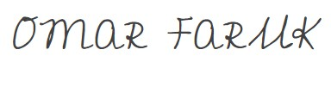

|  |  |
| --- | --- |
| _______________________________  **MD. OMAR FARUK**  ID: 18-36670-1  BSc CSE | _______________________________  **MD. LOTON**  ID: 18-37583-1  BSc CSE |
| Tarek | Noor |
| _______________________________  **TAREK KHAN**  ID: 17-35268-2  BSc CSE | _______________________________  **SAYED ALI NOOR HAQUE**  ID: 17-35423-3  Department |

|  |
| --- |
| Approval |

The thesis titled “Fake News Detection using Machine Learning Classifiers” has been submitted to the following respected members of the board of examiners of the department of computer science in partial fulfilment of the requirements for the degree of Bachelor of Science in Computer Science on (13 August 2022) and has been accepted as satisfactory.

|  |  |
| --- | --- |
| _______________________________  **Mir Md Kawsur**  Lecturer & Computer Science  Department of Computer Science  American International University-Bangladesh | _______________________________  **S.M. Abdur Bhuiyan Rouf**  Assistant Professor & Computer Science  Department of Computer Science  American International University-Bangladesh |
|  |  |
| _______________________________  **Dr. Mahbub Chowdhury Mishu**  Asst. Professor & Head  Department of Computer Science  American International University-Bangladesh | _______________________________  **Professor Dr. Tafazzal Hossain**  Dean  Faculty of Science & Information Technology  American International University-Bangladesh |
|  |  |
| _______________________________  **Dr. Carmen Z. Lamagna**  Vice Chancellor  American International University-Bangladesh | |

**Abstract:**

The majority of smartphone users prefer social media over the internet when it comes to reading the news. The news websites disseminate the news and offer an authenticated source. The issue is how to verify news and articles shared on social media platforms like Twitter, Facebook Pages, WhatsApp Groups, and other microblogs & social networking sites. To take rumors at face value and pass them off as news is detrimental to society. Stopping rumors and focusing on accurate, reliable news stories are urgent needs, particularly in emerging nations like India. This research presents a false news detecting model. The goal is to aggregate the news with the use of machine learning and then use a machine learning classifier to assess if the news is authentic or not. In this research, we present a straightforward Naïve Bayes classifier-based method for false news identification. This method was put into practice as a software solution and evaluated using a dataset. We have been able to categorize data as "Fake News" through our investigation using a variety of machine learning classifiers. Nowadays, the majority of work is completed online. Newspapers that were formerly favored as printed copies are gradually being replaced by online news pieces and social media sites like Facebook and Twitter. Another important source is WhatsApp forwards. The spread of false news only complicates matters and seeks to alter or impede people's attitudes and beliefs about using digital technologies. Using Naïve Bayes, this work enables us to determine the veracity of bogus news because its accuracy rate is better than other classifiers though we use a small dataset. Here, the data is split into a test dataset and a training dataset, and the training dataset is further segmented into groups of data that have similar characteristics. These groupings are then used to match test data, and accuracy is discovered using a Naïve Bayes classifier. Knowing if a certain piece of news is true or false is helpful. Maximum accuracy is provided, and it aids in identifying phony news. Given the relative simplicity of the model, our test set classification accuracy rate is 96% percent. A number of methods are given in the article that might enhance the outcomes.

**Keywords:** Keywords—Machine Learning, Fake News Classification, Bays Net Classifier, Hoeffding Classifier, Naïve Bayes Classifier.

Acknowledgment:

First and foremost, we thank the All-Powerful Allah for enabling us to complete our thesis without experiencing any major hurdles. The second thing we want to do is thank our boss, MIR MD. KAWSUR, for his continuous support and inspiration during our hunt. He was always ready to help whenever we needed it. Finally, we would want to thank our families for everything. It would not be able to pursue this study or earn this undergraduate degree without their ongoing assistance.

Table of Contents

Declaration 2

Approval 3

Abstract 4

Acknowledgment 5

Table of Contents 6

1. Introduction 7
   1. Motivation…………………………………………………… 9
   2. Problem Statement .9
   3. Objective and Contributions………………………………………………......10
   4. Thesis Structure ….….10
2. Literature Review 11
   1. Machine Learning Classifiers 13
      1. Naive Bayes 13
      2. Hoeffding Tree……………………………………………………….15
      3. Bayes Net…….……………………………………………………....16
3. Research Methodology 18
   1. Methodology 18
      1. Script (Pseudo code) 18
      2. Attributes selection 19
      3. Weka classifiers 20
      4. Data preprocessing 21
      5. Feature Extraction 22
4. Experimentation 23
   1. Work on Detecting Fake News in Experiments 23
   2. Dataset for Classification 23
   3. Experimental Results with Different Data Split Ratios 24
   4. Experiment Result 25
   5. Descriptive Analysis 26
5. Result Analysis 26
6. Conclusion 30
   1. Limitation and Scope for future work 31
   2. Reference……………………………………………………………………32-35

Chapter 1

1. Introduction:

Nowadays, a lot of news is published online, but it can be challenging to determine whether the material is true or not. For this situation, fake news detection is crucial. Even if the news is fake, it may not be wholly false. There are occasions when it contains both lies and truths. Social media reports that are inaccurate are referred to as "fake news." It has been employed to discredit some news organizations' critical reporting [1]. In other terms, false information is news that is based on unreliable information. During the 2016 U.S. elections, the top twenty frequently discussed false election stories generated 8,711,000 Facebook shares, reactions, and comments, which helped spread fake news. Ironically, the significance of the 7,367,000 statistics for the top 20 election-related stories that attracted the most attention and had correct, true information was provided by 19 major news websites [2]. In current culture, fake news may be disseminated through a variety of mediums. It can occasionally spread through people and other times through news sources. It can spread by word-of-mouth at times and through news sources at other times. False news is currently most commonly spread via social media and online platforms, including Facebook, Twitter, YouTube, and other websites [3].

First off, during the 2016 American presidential election campaign, when Donald Trump used the term "fake news" to deflect any accusations against him, the general public first became familiar with it. Fake news is abundant on the internet, written by people who want to profit from it by spreading it on Facebook and other social media. They do this by using a website to choose readers through advertising. With each reader click, the author begins to make money. Thanks to the internet and social media, getting access to news information has become much more convenient and simple. The popularity of mobile devices has made it much easier for Internet users to keep up with important happenings online. However, enormous potential frequently results in enormous problems.

Society is significantly impacted by the media, and as is typically the case, someone tries to take advantage of this fact. The media may, on occasion, distort information in a variety of ways to fulfill specific goals. As a result, news articles that are partially or completely false are produced. Furthermore, there are websites that produce almost exclusively false news. They typically use social media to enhance web traffic and the impact of their content, and they deliberately disseminate hoaxes, propaganda, and misleading information presented as news. The main goal of fake news websites is to influence public opinion on various problems (mostly political). China, Germany, Ukraine, the United States of America, and many other countries have examples of these websites [1]. False news is thus both a worldwide issue and a global challenge. Many professionals believe that machine learning and artificial intelligence may be utilized to address the issue of misleading news [4]. There is a reason for that:

Due to more accessible technology and the availability of larger datasets, artificial intelligence systems have recently started to perform noticeably better on various classification problems (such as photo identification, speech detection, and so forth). Several significant papers on automated deceit detection have been published. In Mexico in 2018, false reports of child abduction spread via WhatsApp. A crowd then set two men on fire to death before verifying the veracity of the reports [5]. In India and Myanmar, a similar incident occurred. Additionally, false news on Facebook and WhatsApp prompted fatal acts of violence in Sri Lanka, India, and Myanmar [5]. Fake news has many negative repercussions, and social media is also frequently antagonistic and can occasionally annoy regular authorities as well as the government. It occurs in hospitals, educational institutions, etc. Fake news has the potential to push us against religion, politics, personalities, or organizations, which may result in growth. Fake news is a significant and difficult issue in the globe today. Depending on the circumstance, one false report can duplicate the whole impact of the original and alter the reader's perspective or takeaway. False news is misinformation that certain news editors create in order to profit financially from its distribution. To generate a lot of income for the media organization by gathering/producing news as early as possible and then disseminating it via shares or tweets on social media platforms like Facebook and Twitter. Because people don't try to determine if the material is factual or opinion when looking for news online, fake news spreads quickly. We attempt to fix it. It is, however, quite difficult to totally resolve, but it is possible to lower the prevalence of fake news by detection. For the purpose of identifying fake news, we propose using machine learning approaches.

* 1. Motivation

A recent rumor claimed that certain stoned people were distributing untrue information about the demand for 100,000 human heads for the Padma bridge in Dhaka [6]. It is an entire invention with no basis. On the other hand, some individuals are relying on a 2015 report which asserts that workers from the Chinese construction company hired to build the bridge sacrificed goats and calves during the project's initial stage. The Chinese laborer thought one could appease God and avert horrible calamities by offering animals. Stories of killing young children for a bridge and images of human blood being used in animal sacrifices are spread. It will be beneficial to identify this form of news and fake news.

* 1. Problem Statement

Due to fake news, stoning is rising in several countries, including Bangladesh. Due to the spread of false information, Padma Bridge is on the other side. People must use their common sense, and the COVID-19 pandemic is worsening. According to a countrywide survey carried out by the Management and Resources Development Initiative (MRDI) with the assistance of Unicef, 63.7 percent of Bangladeshis have mistakenly believed material they have obtained online or through social media to be true. And over two-thirds of individuals never or rarely check the news outlet that first reported it [7]. We want to do everything we can to fight it since it has grown to be a significant problem on a global scale. Even though fact-checking websites like USAFacts, Jachai, and Rumor Scanner exist, these networks are typically user-based services. Users identify fraud and report it on their own, and erroneous reporting can frequently result in a biased group of individuals distorting the context. An automated system would be more straightforward and more structured as a result.

Additionally, the systems in place today are inadequate for deciphering Bangla letters and words. It's imperative to have a model that can read and comprehend English letters and words because nearly every model created so far can function with English letters and words. Anyone receiving fake news through a messaging app, such as WhatsApp, Imo, or Viber, cannot verify whether the news is true. Therefore, we will need a system that can handle all of these problems to get around the limitations of current models.

* 1. Objective and Contributions

A tool that can identify and eliminate fraudulent sites from the results presented to a user by a search engine or a social media news feed is proposed as a solution to the problem of false news. To validate the answer, we have to employ WEKA machine learning. The user can download the program and then add it to their news reader's browser or application. Once it's up and running, the tool will utilize various techniques, including ones that look at a link's syntactic properties, to assess whether it should be included in the search results.

* 1. Thesis Structure

A number of chapters make up our thesis document as a whole. All of our works have been individually described. Including an overview of the literature review, algorithms, and methods, Chapter 2's background study provides background information. The summary of the several publications that we have read through and compared is included in the literature review. We have added about ten papers that are pertinent to our work despite having read a large number of research papers. We have utilized a variety of classifiers in our work, and methods contain those as well. These classifiers include the Naive Bayes in the Machine Learning classifier.

Chapter 2

2. Literature Review

[8] This paper used feature extraction (TF-IDF VIEW count Vectorizer) and tools (NLP NLTK libraries and SAFAR v2) to fast clean the speech before employing a conventional machine learning technique to determine whether it was true or not. To obtain better statistical values, it also utilized POS (Part of Speech). Half of the data in the dataset are fake, and the other half is true. The data was then subjected to six algorithms (XCboost, Random forest, Naive Bayes, K-Nearest Neighbors(KNN), Decision Tree, SVM), and a confusion matrix was created. The XGboost system had the highest accuracy rate, at 75%. The lowest Naive Bias score was 65%. BUT SVM (The Machine Vector) and Random forest with an accuracy of about 73%. We must appreciate the textual analysis technique if I'm going to talk about how valuable this work is. They applied a variety of techniques to obtain sensitive data, however, if feature extraction and tolls were increased, their results would be noticeably better.

[9] This study utilized a naive Bayes classifier to identify false news. The Buzzfeed News data set was used to train and evaluate the naive Bayes algorithm. Each Facebook post in the data set corresponds to a news story. Some of the news values in those articles are null values, while others are true and false combinations. The training data set, validation data set, and test data set are the three subsets that make up the entire data set. These three subsets are utilized to achieve an unbiased estimation, tune some global parameters, and train the naïve Bayes classification algorithm. The categorization accuracy for a true and false news story is nearly the same once the data set has been calculated. Accuracy for true news was 75.59 percent, compared to 71.73 percent for fake news. however, 4.9% of the data set's totally fake news is contained inside. The data set is really little for this paper. Big data requires study before they can simply comprehend it. They didn't utilize it for noise removal, only for feature extraction and charging. After all, they may quickly compare the outcome with the implementation of precise data and the use of different techniques. Thus, using them in numerous sophisticated approaches would greatly improve the categorization results.

The term frequency-inverse document (TF-IDF) of the bag of words and n-grams is used by the authors of [10] to extract features, and a support vector machine (SVM) is used as a classifier. The Kaggle website is where these datasets were found. To identify fake news, they were paying attention to the wording, source, date, and sentiment. This essay demonstrates how much better results might be obtained by properly analysing sentiment. SVM was used to obtain a significant level of accuracy on the dataset. When discussing the benefits of this study, we can appreciate how text pretreatment with cleaning approaches has a big impact on accuracy. It would be pertinent to expand on this work with a larger data set and develop its supervised learning through another website for continual updating and automatic integration of fake news.

[11] The writers of this research employed a variety of methods to determine the outcome. The data set was gathered by the researcher in SUSI, Bangladesh. They used a variety of pre-processing approaches, including corpus, stop words, URL removal, number removal, and punctuation removal, to obtain sharp data. Also used for feature extraction is term-frequency (TF-IDF). After completing their initial steps, they experimented with a variety of classifiers, including Naive Bias and Passive-Aggressive Classifiers (PAC). The Naïve Bayes Classifiers all produce average accuracy of 93.2 percent and 93.5 percent, respectively, for the greatest accuracy rate of 93.8 percent. For this paper, the majority of the classifiers had an accuracy of over 90%. If they are included in Feature Techniques, Wor2Vec, it will be more beneficial.

[12] Use the Support Vector Machine (SVM) and Naive Bayes classifier to identify fake news on Facebook, Instagram, and Twitter. They examined a social media data set. They were unable to specify the techniques used for feature extraction and data pre-processing in this study, despite the accuracy average of this paper being up to 93.6. When discussing the paper's drawbacks, I may point out that numerous intricate algorithms and vectorization were required in order to make it simple to compare which methods were the best. They will achieve a superior outcome regardless of whether all the approaches are used.

[13] They proposed a method in this research that can effectively identify fake news in Bangla. Their dataset had undergone some pre-processing and feature extraction approaches. Passive-aggressive classifier and Support Vector Machine (SVM) both obtained 93.8 percent and 93.5 percent accuracy, according to the examination of real-world data. For categorization, they gathered a sizable dataset of 51.8k data. They stopped words and eliminated punctuation from this paper. utilizing the Passive-Aggressive classifier, Naive Bayes classifier five different way experiment of algorithms. But for this dataset, these two algorithms outperformed all others in terms of accuracy. The topic of feature extraction, which has to be addressed more, comes up when we talk about the limits of this research.

**2.1 Machine Learning Classifiers**

We have used Three classifiers in our proposed model to detect English international fake news.

**2.1.1 Naive Bayes:**

An approach for supervised machine learning that makes use of the Bayes theorem is known as a Naive Bayes classifier. One of the simplest and effective classification algorithms now in use is the Naive Bayes Classifier. It facilitates the creation of efficient machine learning models that are capable of making precise predictions.

Given that it is a probabilistic classifier; it bases its predictions on the likelihood that a given object would manifest. The model's generating variables are independent of one another. It has been demonstrated that the results produced by this classifier are generally quite satisfactory. [14]

The formula for Bayes' theorem is given as:

Naïve Bayes Classifier Algorithm

Where,

The posterior probability, or P(A|B), measures the likelihood that a given hypothesis (A) will really occur.

P(B|A) stands for Likelihood Probability, which measures how likely it is based on the evidence at hand that a given hypothesis is correct.

Priority probability, or P(A), is the likelihood of a theory before seeing the evidence.

The probability of evidence is a marginal probability, or P(B)

Four Naive Bayes algorithm applications. [15]

Real-time Prediction: Naive Bayes is a quick classifier that is eager to learn. As a result, it might be applied to real-time prediction.

This algorithm is very widely renowned for its ability to predict many classes. Here, we can forecast the likelihood of several target variable classes.

Sentiment analysis, spam filtering, and text classification: Because they perform better in multi-class situations and follow the independence criterion, naive Bayes classifiers are frequently employed in text classification and have a greater success rate than other methods. It is therefore frequently used in Sentiment Analysis and Spam Filtering.

**Recommendation System:** By merging Naive Bayes Classifier and Collaborative Filtering, this system filters opportunistic data and predicts whether a user would find a specific resource appealing or not.

**NAIVE BAYES CLASSIFIER AND ITS USES**

A component of rudimentary machine learning in artificial intelligence is the naive Bayes classifier. With the use of multinomial NB and pipelining ideas, the widely used Naive Bayes algorithm determines if a piece of news is accurate or not. It is not the only approach for training these classifiers since many other algorithms also concentrate on common principles. Using nave Bayes, it is possible to determine whether the news is authentic or fraudulent.

Text categorization uses this particular type of method. With the help of a naive Bayes classifier, token usage is connected to the news that may or may not be false, and the Bayes theorem is then used to determine the news' correctness.

**2.1.2 Hoeffding tree:**

A decision tree learning technique for identifying stream data is the Hoeffding tree algorithm. Initially, it was used to track web clickstreams and develop models that predicted which web providers and websites a person would visit most frequently. It frequently operates in sublinear time and generates a decision tree that is very similar to that of batch learners. The fundamental concept that the data is not changing over time is necessary to construct a Hoeffding tree[16]. With the help of this approach, a decision tree can be built and expanded based on the guarantees offered by the additive Chernoff constraint. The tail distribution of the total of independent random variables has constraints that are exponentially declining, according to a branch of probability theory called the additive Chertoff bound. These bounds are more accurate when compared to other tail bounds, such as Markov inequality. This probabilistic method enlarges any node in Hoeffding decision trees with sufficient support for an optimal splitting feature. It is easier to use the idea that a smaller sample size can give enough evidence to choose the appropriate splitting attribute by using the informal term "additive Chertoff bound." The additive Chertoff limit, sometimes referred to as the Hoeffding

bound, fundamentally offers values in observation quantity that can help estimate any statistical outcomes within a given range of results.

Assume that N independent observations are made of the random variable r, an attribute selection measure, over the whole range of its possible values. (For a probability, R equals one; for an information gain, it equals log c, where c is the number of classes.) R represents information gain in the context of Hoeffding trees. If we calculate the sample's mean, r', the Hoeffding bound implies that the true mean of r must be at least r’−ε with probability 1−δ.where δ is the user-specified value, and

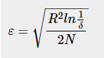

When choosing a splitting attribute at a node, the Hoeffding Tree algorithm uses the Hoeffding bound to find, with high probability, the minimum number, N, of examples required. Unlike the majority of other bound equations, the Hoeffding bound is not dependent on the probability distribution.

**2.1.3. Bayes Net:**

A directed acyclic graph is used in a Bayesian network, also known as a Bayes network, Bayes net, belief network, or decision network, to represent a set of variables and their conditional relationships (DAG). When determining the chance that any one of a number of potential known causes contributed to an event that already happened, Bayesian networks excel. A Bayesian network, for instance, could depict the probability connections between diseases and symptoms. The network can be used to calculate the likelihood that a certain set of diseases will be present given a set of symptoms.

**2.1.3.1. sNML-based predictive parameterization**

We suggest a non-Bayesian substitute for discovering Bayesian network parameters that are effective for prediction in research paper V. The concept is to use the so-called sequential normalized maximum likelihood (sNML) equation-leading parameters.



Where  An example of this method of learning the parameters is shown in Figure 3.1.

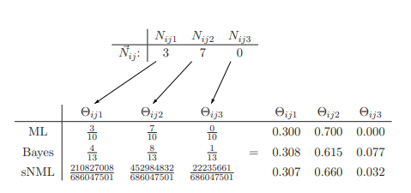

Figure 3.1: Learning the parameters in three different ways for the counts N~ ij = (3, 7, 0). In the Bayesian case, the hyper parameters were set by αijk = 1.0.

**2.1.3.1. Tokenization**

The Bayesian filter works with the individual small parts of the text, the so called tokens. This very simple hierarchic model fits to the Bayesian model and it does not count with the dependency between tokens. Many filters work with simple word-by-word tokenizing, where the text is separated into words and the words have their own values in the token-dictionary. In this case, one word will be one token. However, some filters offer word-pair tokenization, which requires more maintenance and more resources for calculating, but it leads to better filtering accuracy. For example: the word “software” and the world “cheap” can be also found in legitimate e-mails, but the word-pair “cheap software” can be a strong indicator of being spam. The dictionary should be updated with all the new tokens from the processed e-mail. After the tokenization, the tokens are handled separately, what means that the order of the tokens is taken into consideration.

**Chapter 3**

**Research Methodology**

**3.1. Methodology**

The procedure is completed in two phases. Finding a reliable reference database was the first phase, after which it was necessary to compute the characteristics and create the data files for WEKA. That was difficult so to gather URLs for the clickbait, we crawled the internet. We concentrated on social media websites like Facebook, Google, and Twitter which are more likely to have more fake news or clickbait advertising or stories.

In the second phase, a Script (pseudo code) calculated the properties from the title and the content of the web pages after collecting URLs in a file. Finally, from the web pages, we extracted the features. The features include English keywords, titles that begin with numbers, all-caps words, questions, and exclamation marks if the user quickly exited the website and title-related content.

**3.1.1 Script (pseudo code)**

To validate the answer, we have to apply WEKA machine learning [19]. We used the script below to extract the parameters required to funiculate WEKA because WEKA has certain requirements for its input. In every experiment, ten-fold cross-validation was utilized.

Compute fake news website attributes,

1: Open URL file

2: for each title

3: title starts with a number? 1 → output file

4: what title contains? and/or! marks? 1 → output file

5: all words are capital in the title? 1 → output file

6: Do users leave the website after visiting? 1 → output file

7: Do contents have no words from the title? 1 → output file

8: title contains keywords? No Keywords → output file

9: end for

**3.1.2. Attributes selections**

We rank the attributes using a number of methods after reading the websites' attributes file into WEKA in order to select the most relevant ones in order to improve accuracy and shorten training time.

By assessing the information gain in relation to the class, Info Gain Attribute Eval assesses the value of an attribute. In the expression Info Gain (Class, Attribute) = H(Class) H (Class| Attribute). It basically counts the amount that each feature helps to reduce the volatility overall. The definition of the entropy, H(X), is as follows.

H(X) = −sum (Pi ∗ log2(Pi))

Pi is the chance that the class I in the dataset exists, and log2 is the base 2 logarithm (in WEKA, the natural logarithm of base e is used, but we pick log2). Entropy essentially counts how "impure" something is. The closer it is to 0, the lower the impurity level in your dataset is. Therefore, a good attribute is one that includes the most information, or minimizes the entropy, the most [20].

Correlation Attribute Eval calculates an attribute's value by calculating its Correlation test with the class. The evaluation of nominal attributes is performed value by value, using each value as an indicative. A weighted average is used to determine an overall correlation for a nominal attribute. An indicator for a nominal attribute's value is therefore a numeric binary attribute that takes on the value of 1 when the value appears in an instance and 0 otherwise.

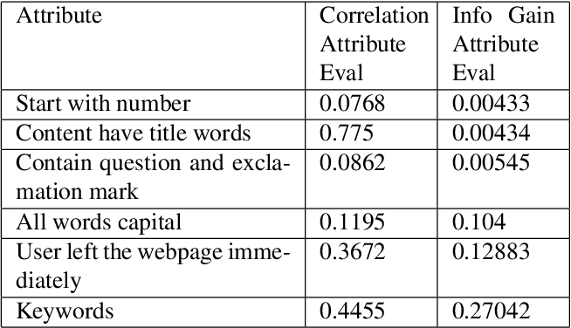

Table 1: Attribute selection

**3.1.3. Weka classifiers**

**3.1.3.1**. Naïve Bayaes: Class for an estimator-based Naive Bayes classifier. Based on a study of the training data, numerical estimator precision values are selected. The classifier is not an Update Able Classifier as a result (which in typical usage are initialized with zero training instances) [21].

**3.1.3.1**. Hoeffding tree: For big data streams, the Hoeffding tree is an incremental decision tree learner that operates on the presumption that the distribution of the data is not changing over time [22]. A decision tree based on the theoretical assurances of the Hoeffding bound is progressively grown (or additive Chernoff bound).

**3.1.3.1**. Bayes Net: Bayes Network learning utilizing various search methods and performance indicators. Base class for a Bayes Network classifier. provides tools and data structures common to Bayes Network learning algorithms like K2 and B, such as network structure and conditional probability distributions [23].

Bayes Net networks are excellent at analyzing an event that already happened and determining the likelihood that any one of multiple potential known causes was a contributing element. To illustrate the probability links between diseases and symptoms, a Bayesian network could be used.

**3.1.4. Data pre-processing**

The act of converting unprocessed data into a format that is well suited to our requirements is known as data pre-processing. Data from the real world is not always accurate and reliable. These data are inaccurate and don't reflect certain patterns or habits. These issues can be resolved with data pretreatment. Data pre-processing appropriately prepare raw data for additional processing. Data pre-processing in Machine Learning (ML) procedures changes the dataset into a format that the algorithm can quickly comprehend and parse [24].

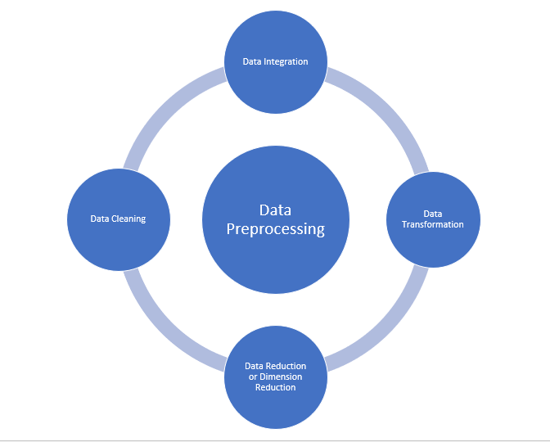

Figure 4: Data flow of Data Pre-processing

Several procedures are used while preparing data. We started by cleaning the raw dataset of punctuation marks, numbers, null values, duplicate entries, etc. Next, we eliminated stop words. Filtering away words with minimal significance is done by removing stop words. We placed all the data in two distinct forms in order to have it in a clear and standardized manner for further analysis.

A corpus is a group of texts. Using the Pandas data analysis toolkit in Python, we converted the dataset into corpus format and placed it into a Data frame, which is essentially a table.

URL are links or metadata references, as well as (if applicable) HTML tags, in the text. These links don't offer any useful information. Pre-processing involved removing the URLs from the dataset.

**3.1.5. Feature Extraction**

Feature extraction is a method for obtaining data that illustrates the significance of a certain word or phrase within a corpus. One of the greatest feature extraction methods was utilized in our dataset, called Term Frequency Inverse Document Frequency (TF-IDF). Since the corpus cannot be passed directly into classification models, TF-IDF transforms it into usable features. The Term Frequency (TF) approach compares the number of times a word appears in a sentence to the total number of words in the phrase. Additionally, the Inverse Document Frequency (IDF) technique calculates the frequency of a term across all phrases. The sum of the values of the TF and IDF is the TF-IDF value. The more uncommon a word or phrase is, the higher its TF-IDF value. [25]

To utilize TF-IDF, we added the "TfidfVectorizer" from the scikit-learn library. The formula does not need to be manually written. After importing the library, we produced a "TfidfVectorizer" object. We used that object to invoke the fit transform(corpus) method in an array, passing our corpus as a parameter.

This function initially turns each word into a vector. Then it employs Cosine Similarity, which gauges how similar two or more vectors are to one another. Finally, it delivers the complete corpus's TF-IDF values in numerical form.

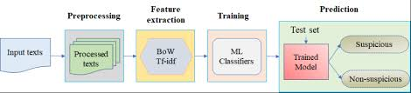

Fig 5: Feature Extraction with T

**Chapter 4**

**Experiment:**

**4.1. Related Work on Fake News Detection:**

[26] identified a number of media sources and conducted the necessary research to determine whether the provided article was authentic or not. The research makes use of predictive models that don't fit with the other existing models as well as models based on speech features. [27] uses the Naive Bayes classifier to identify bogus news. An accuracy of 96% was achieved using this technology, which was used as a software framework and tested with using records from Facebook, etc. The paper's correctness suffered because the punctuation mistakes were ignored. [28] estimated different machine learning (ML) methods and conducted research on prediction accuracy. Different predictive patterns, such as bounded decision trees, gradient improvement, and support vector machines, had varying degrees of accuracy. The patterns are estimated with an accuracy of 90–96% using an inaccurate probability threshold. [28] used the Naive Bayes classifier and discussed how to integrate fake news detection into several social media platforms. They accessed news through Facebook, Twitter, and other social media platforms. Because this website's information is not entirely reputable, accuracy is very poor. [29] [30] [31] talk about tracking down false rumors in real-time. It makes use of a novelty-based trait and gets its data from Kaggle. This pattern has an average accuracy rate of 90% percent. Clickbait and sources that are not regarded as unreliable have lower resolution [32].

**4.2. Dataset for Classification:**

There are 1.1k data in our rather little dataset for classification. The remaining 4% of them, however, are made up of phony news, while 96% of them are real data. It is clear that the fake and real datasets have a significant difference. The results would have been biased in favor of real news if we had used the complete dataset. Therefore, the model wouldn't be the best model to categorize any data. In order to prevent the model from producing skewed results, we extracted 96% real data and 4% artificial data from the dataset.

**4.3. Experimental Results with Different Data Split Ratios**:

[39] There are a few criteria to follow while selecting the right ratio for the data test train. We experimented with various split ratios for our model to see how it would respond to them. We encounter bogus news very frequently in real life, yet for logistical reasons, real news predominates in our feeds. Here are a few of the outcomes using various train test ratios.

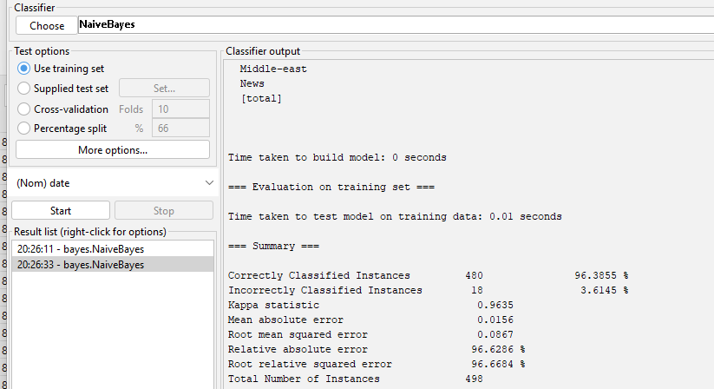

**Figure 1:** Naive Bayes Train Test Result

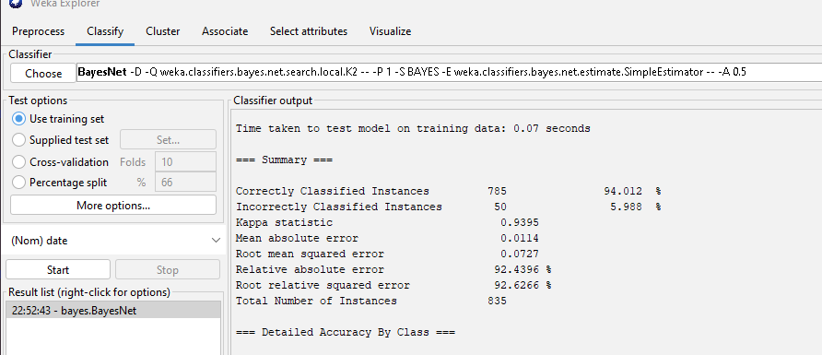

**Figure 2:** Bayes Net Train Test Result

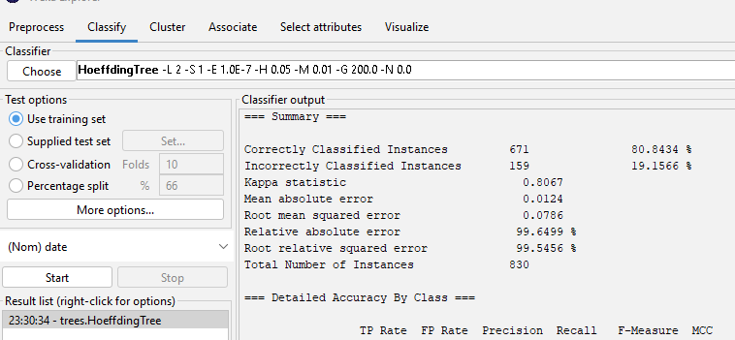

**Figure 3:** Hoeffding tree Train Test Result

**4.4. Experiment Result:**

The output from the machine is nearly accurate. Everyone is aware that no machine can provide a 100% percent accurate result. Additionally, although not for all features, our constructed model provides a respectable result. It occasionally reacts to incorrect data pertaining to the dataset. However, the majority of the responses reflect what we want to happen. Using the split technique, we train our model. Our dataset was 80/20 split. To obtain the most accurate result possible, we applied 5 distinct models of machine learning algorithms. And finally, when we use the machine learning system to detect bogus news, we receive results that are 92.6% correct.

**4.5. Descriptive Analysis:**

Before applying models to the English dataset, we apply these models to the English dataset for detecting fake news. We have tested our system in noisy and noise-free environments and our result is quite satisfactory. We have tested the accuracy of the system by testing the dataset using a different model. But we have found some problems in a noisy environment. As in a noisy environment, the system was getting confused with the other noisy commands. So the accuracy level in a noise-free environment is quite praiseworthy in terms of the accuracy level of the system in a noisy environment. So above all, this system can cope uith all the surrounding problems and we are working to solve the nonissue.

Chapter 5

Result Analysis:

Outstanding results are consistently produced by the naïve Bayes classifiers. The majority of the classifiers we used had accuracy rates of over 96%. Relative absolute error for the 830 examples with detailed accuracy by class was 97.13 percent, naive Bayes was 96% percent, and altogether, there were 11.77 percent of cases that were incorrectly classified. The Hoeffding tree correctly detected occurrences in 80.60 percent of cases, and incorrectly categorized them in 19.39 percent of cases. Bayes net accuracy result less naïve Bayes 94% to 96%. Bayes net and Hoeffding tree correctly classified instances are higher than Nave Bayes according to the data, but the relative error is higher than Naive Bayes and is 2.5 percent, while incorrectly classified instances are lower than Naive Bayes and are around 3.38 percent. Kappa statistic 1 and the Mapped classifier, respectively, are identical to the Random tree classifier as well. The results are more than 96% percent accurate when we utilize the machine learning algorithm to identify fake news.

The Naïve Bayes classifier are more accurate than the others.

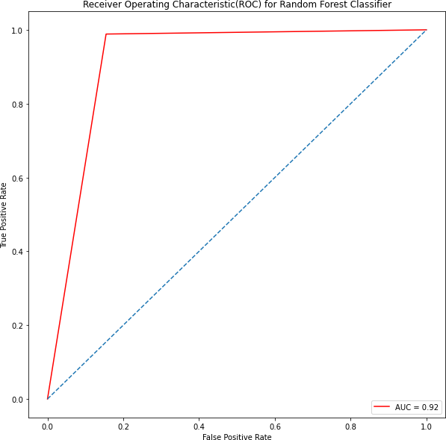

**Figure 5.6: Confusion Matrix and Naïve Bayes Classifier**

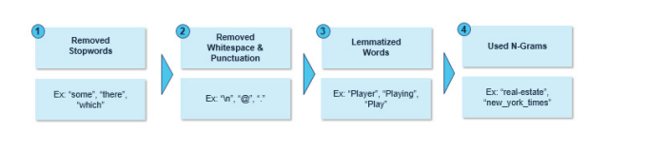

Fig1: Pre-processing of text data

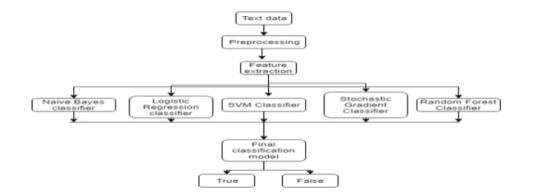

Fig2: Classifier Prediction Model

The number, quality, and properties of the text data (or corpus), as well as those of the text vectors, may all affect how well a classifier performs. When it comes to text feature extraction, common noisy words, often known as "stop words," are less important because they only increase the dimensionality of the feature set rather than the sentence's actual substance. To improve performance, they could be disregarded.

This decreases the size and dimensionality of the text corpus and adds text context for feature extraction. Another method for distilling language is lemmatization, which reduces a large number of words to a single discrete representation [10].

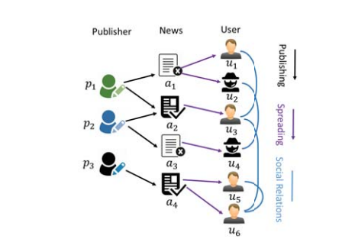

Fig 3: Relationship Between user and publisher

Most of the classifiers we have used gave an accuracy rate of over 96%. The following table shows the detailed result of our model-

|  |  |  |  |
| --- | --- | --- | --- |
| Sr. No. | Algorithm | Correctly classified | Incorrectly classified |
| 1 | Naïve Bayes | 96.3855% | 3.6145% |
| 2 | Bayes Net | 94.012% | 5.988% |
| 3 | Hoeffding tree | 80.8434% | 19.1566% |

Chapter 6

Conclusion:

Therefore, using the nave Bayes theorem, we can draw the conclusion that any news from a large or small dataset may be categorized as false or real news by matching it with the values of the prior dataset in less time, which in turn enables the users to trust in a piece of certain news. The research demonstrated that Bays Net and the Hoeffding tree produce outcome over 80 percent but better accuracy get from Naive Bayes and it is 96 percent. When trained to recognize phony news, which is a crucial skill. Through our analysis, we were able to classify data using a number of machine learning classifiers such as "Fake News." Before training and testing the system, we first acquired datasets containing genuine and fake news. As part of the preparation phase, we also eliminated stop words, digits, and other formatting components from the dataset. The dataset's headings and content were then combined. Seeking to apply the classifiers, the outcome was exactly what we were after. The Naïve Byes classifiers beat the other machine learning classifiers overall, with a 96 percent accuracy rate. We exclusively utilize English terminology and articles; we don't study other languages like Bangla. If future researchers want to study this topic, they will have a decent idea of which classifier to use for their model. Weka works well both in small and large datasets, however, it is first effective with tiny datasets. There are a lot of unresolved problems with fake news identification that need study attention. For instance, understanding the crucial components involved in news dissemination is a crucial first step in reducing the spread of fake news. The main sources engaged in the dissemination of false news may be found using machine learning techniques. Real-time false news detection in videos is another potential future trend. The study demonstrated that even a very basic artificial intelligence machine, such as a naïve Bayes classifier, may produce promising results on a crucial issue like the identification of bogus news. The findings of this study further support the idea that this significant issue may be successfully solved using artificial intelligence approaches.

Limitation and Scope for future work

There have been several initiatives to address the issue of false news, but none have been very successful.

The most effective models get better every day thanks to the enormous volumes of data that social media networks like Facebook, Twitter, etc. collect. The usage of deep neural networks makes the work in this area more promising in the future.

This problem has certain drawbacks since the data is irregular, which makes it possible for any prediction model to contain errors and abnormalities. Future developments may make use of ideas like topic modelling, word2vec, and POS tagging. These will significantly increase the depth of the model in terms of feature extraction and precise classification.

Word2Vec: Using this method, the associations between words in a corpus are preserved while text is converted to features. One of the greatest feature extraction approaches in NLP, it combines several techniques. In most cases, a pretrained vectors model (like GloVe) is utilized, and transfer learning can be applied to create a better model.

Topic modelling: News stories can cover a wide variety of subjects. If realistic results are needed, label-based categorization alone is insufficient. Topic modelling is a sophisticated approach that can be useful in this situation. Making predictions using topic modelling, which groups each text into subjects, is more precise. Latent Dirichlet Allocation, generally known as LDA, is the most widely used topic modelling approach in NLP. LDA use can give the challenge of identifying bogus news another level of complexity.

References

[1] Jr., E.C.T., Lim, Z.W., Ling, R.: Defining ¡°Fake News.¡± https://doi.org/10.1080/21670811.2017.1360143. 6, 137?

[2] ZhouXinyi, ZafaraniReza: A Survey of Fake News. ACM Comput. Surv. 53, (2020).153 (2017). <https://doi.org/10.1080/21670811.2017.1360143>.

<https://doi.org/10.1145/3395046>.

[3] ShuKai, SlivaAmy, WangSuhang, TangJiliang, LiuHuan: Fake News Detection on Social Media. ACM SIGKDD

Explore.Newsl. 19, 22?36 (2017). <https://doi.org/10.1145/3137597.3137600>

[4] Cade Metz. (2016, Dec. 16). The bittersweet sweepstakes to build an AI that destroys fake news. [Online]. Available: https://www.wired.com/ 2016/12/bittersweet-sweepstakes-build-ai-destroys-fake-news/

[5] Fake news websites. (n.d.) Wikipedia. [Online]. Available:

https://en.wikipedia.org/wiki/Fake_news_website. Accessed Feb. 6, 2017.

[6]<https://globalvoices.org/2019/07/20/fake-news-human-sacrifice-padma-bridge-violence-bangladesh/>

# [7] Inoculating Against Fake News About COVID-19, url: [www.frontiersin.org/articles/10.3389/fpsyg.2020.566790/full](http://www.frontiersin.org/articles/10.3389/fpsyg.2020.566790/full)

[8]. Khanam, Z., Alwasel, B.N., Sirafi, H. and Rashid, M., 2021, March. Fake news detection using machine learning approaches. In *IOP Conference Series: Materials Science and Engineering* (Vol. 1099, No. 1, p. 012040). IOP Publishing.

[9]. Granik, M. and Mesyura, V., 2017, May. Fake news detection using naive Bayes classifier. In *2017 IEEE’s first Ukraine conference on electrical and computer engineering (UKRCON)* (pp. 900-903). IEEE.

[10]. Smitha, N. and Bharath, R., 2020, July. Performance comparison of machine learning classifiers for fake news detection. In *2020 Second Conference on Inventive Research in Computing Applications (ICIRCA)* (pp. 696-700). IEEE.

[11]. Sraboni, T., Uddin, M., Shahriar, F., Rizon, R.A. and Polock, S.I.S., 2021. *FakeDetect:* Bangla fake news detection model based on different machine learning classifiers (Doctoral dissertation, Brac University).

[12]. Jain, A., Shakya, A., Khatter, H., and Gupta, A.K., 2019, September. A smart system for fake news detection using machine learning. In *2019 International Conference on Issues and Challenges in Intelligent Computing Techniques (ICICT)* (Vol. 1, pp. 1-4). IEEE.

[13]. Balo, A., Islam, J. and Baki, A.A., 2019. Bengali Fake News Detection Using Machine Learning.

## [14]. Jain, M. S., n.d. Naive Bayes Classifiers. [Online] Available at: https://www.geeksforgeeks.org/naive-bayes-classifiers/

## [15]. Ray, S., n.d. *6 Easy Steps to Learn Naive Bayes Algorithm with codes in Python and R.* [Online] Available at: <https://www.analyticsvidhya.com/blog/2017/09/naive-bayes-explained/#:~:text=Naive%20Bayes%20Model-,What%20is%20Naive%20Bayes%20algorithm%3F,presence%20of%20any%20other%20feature>. [Accessed December 2013].

## [16]. M., M., 2013. What is Hoeffding Tree Algorithm?. [Online] Available at: https://www.tutorialspoint.com/what-is-hoeffding-tree-algorithm

## [17]. Jaiswal, S., 2011. BayesNet Algorithm. [Online]

## https://en.wikipedia.org/wiki/Bayesian_network

## [18]. T. You, “Understanding Bayes Net,” Towards Data Science. com. June, vol. 12, 2019.

## [19]. Aldwairi, M. and Alwahedi, A., 2018. Detecting fake news in social media

## networks. *Procedia Computer Science*, *141*, pp.215-222.

[20]. Shu, K., Sliva, A., Wang, S., Tang, J. and Liu, H., 2017. Fake news detection on social media: A data mining perspective. *ACM SIGKDD explorations newsletter*, *19*(1), pp.22-36.

[21]. Granik, M. and Mesyura, V., 2017, May. Fake news detection using naive Bayes classifier. In *2017 IEEE first Ukraine conference on electrical and computer engineering (UKRCON)* (pp. 900-903). IEEE.

[22]. Khanam, Z., Alwasel, B.N., Sirafi, H. and Rashid, M., 2021, March. Fake news detection using machine learning approaches. In *IOP Conference Series: Materials Science and Engineering* (Vol. 1099, No. 1, p. 012040). IOP Publishing.

[23]. Reis, J.C., Correia, A., Murai, F., Veloso, A. and Benevenuto, F., 2019, June. Explainable machine learning for fake news detection. In *Proceedings of the 10th ACM conference on web science* (pp. 17-26).

[24]. Manzoor, S.I. and Singla, J., 2019, April. Fake news detection using machine learning approaches: A systematic review. In *2019 3rd international conference on trends in electronics and informatics (ICOEI)* (pp. 230-234). IEEE.

[25]. Sharma, U., Saran, S. and Patil, S.M., 2020. Fake news detection using machine learning algorithms. *International Journal of Creative Research Thoughts (IJCRT)*, *8*(6), pp.509-518.

[26] Granik, Mykhailo, and Volodymyr Mesyura. "Fake news detection using naive Bayes classifier." In *2017 IEEE first Ukraine conference on electrical and computer engineering (UKRCON)*, pp. 900-903. IEEE, 2017.

[27] Gilda, S., 2017, December. Notice of violation of IEEE publication principles: Evaluating machine learning algorithms for fake news detection. In *2017 IEEE 15th student conference on research and development (SCOReD)* (pp. 110-115). IEEE.

[28] A. Jain and A. Kasbe, "Fake News Detection," 2018 IEEE International Students' Conference on Electrical, Electronics and Computer Science (SCEECS), 2018, pp. 1-5, doi: 10.1109/SCEECS.2018.8546944.

[29] Granik, M. and Mesyura, V., 2017, May. Fake news detection using naive Bayes classifier. In *2017 IEEE first Ukraine conference on electrical and computer engineering (UKRCON)* (pp. 900-903). IEEE.

[30] Gilda, S., 2017, December. Notice of violation of IEEE publication principles: Evaluating machine learning algorithms for fake news detection. In *2017 IEEE 15th student conference on research and development (SCOReD)*

[31] Akshay Jain and AmeyKasbe. “Fake News Detection.” 2018 IEEE International Students' Conference on Electrical, Electronics and Computer Science (SCEECS): IEEE. 2018.

[32] Gilda, S., 2017, December. Notice of violation of IEEE publication principles: Evaluating machine learning algorithms for fake news detection. In *2017 IEEE 15th student conference on research and development (SCOReD)* (pp. 110-115). IEEE.

[33] Sraboni, T., Uddin, M., Shahriar, F., Rizon, R.A. and Polock, S.I.S., 2021. *FakeDetect: Bangla fake news detection model based on different machine learning classifiers* (Doctoral dissertation, Brac University).

[34] Elias Hossain, M., Kaysar, N., Joy, A.Z.M.J.U., Rahman, M.M. and Rahman, W., 2021. A Study Towards Bangla Fake News Detect